Scientific Computing

MATH6183001

**NUMERICAL INTEGRATION**

There are several methods:

0. Riemann Integral

1. Trapezoidal Rules and Composite Trapezoidal Rules

2. Simpson’s 1/3 Rules and Composite Simpson’s 1/3 Rules

3. Simpson’s 3/8 Rules and Composite Simpson’s 3/8 Rules

4. Romberg Integration

5. Gauss Integration

**0. RIEMANN SUM: LEFT, RIGHT, MIDPOINT**

Example: Find the area bounded by y = x2, x = 0, x = 8 and x axis using 4 sub-intervals and

a. left Riemann sum

b. right Riemann sum

c. midpoint Riemann sum

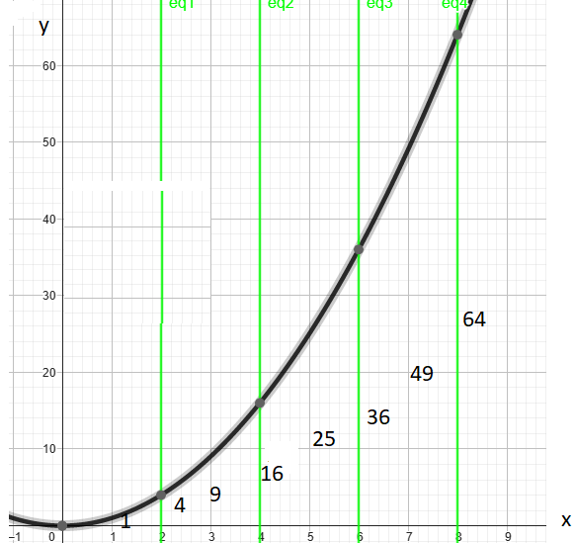

**1. Trapezoidal and Composite Trapezoidal Rules**

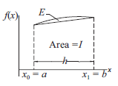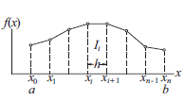

Trapezoidal:



Composite Trapezoidal:



Truncation Error for composite trapezoidal:



Example:

Find $\int_{0}^{π}{sin⁡(x) dx}$ using:

a. exact value 5 d.p.

b. Composite Trapezoidal Rule with 2 panels, 5 d.p. What are the boundaries?

c. Composite Trapezoidal Rule with 4 panels, 5 d.p. What are the boundaries?

d. Composite Trapezoidal Rule with 8 panels, 5 d.p. What are the boundaries?

e. What is your conclusion from a,b,c,d?

**2. Simpson’s 1/3 Rule and Composite Simpson’s 1/3 Rule.**

This method is based on quadratic approximation. For Composite Simpson’s 1/3 Rule the number of panels must be **even**.

Simpson’s 1/3 Rule:



Composite Simpson’s 1/3 Rule:

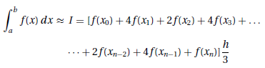

Example:

Find $\int_{0}^{π}{sin⁡(x) dx}$ using Composite Simpson’s 1/3 Rule, 5 d.p with

a. 2 panels

b. 4 panels

c. 8 panels

Error for Simpson’s 1/3: $E≤\frac{\left(b-a\right).h^{4}.K}{180}$, $K=max\left|f^{\left(4\right)}(ξ)\right|$

**3. Simpson’s 3/8 Rule and Composite Simpson’s 3/8 Rule**

This method is based on cubic approximation. For Composite Simpson’s 3/8 Rule the number of panels must be **multiple of 3**.

$I=\frac{3h}{8}\left[f\left(x_{o}\right)+3f\left(x_{1}\right){+3f(x}_{2}\right)+f(x_{3})]$. And the composite is:

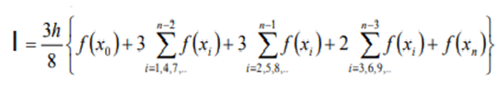

To memorize:

* The coefficients for the initial and terminal point are = 1
* The coefficients for the points xi (multiple of 3) are = 2
* The coefficients for the remaining points are = 3

Example:

Find $\int_{0}^{π}{sin⁡(x) dx}$ using Composite Simpson’s 3/8 Rule, 5 d.p and:

a. 3 panels

b. 6 panels

c. 9 panels

Example:

|  |  |  |  |  |  |  |
| --- | --- | --- | --- | --- | --- | --- |
| $$x$$ | 0 | 0.5 | 1 | 1.5 | 2 | 2.5 |
| $$f(x)$$ | 1.5 | 2 | 2 | 1.6364 | 1.25 | 0.9565 |

Find $\int_{0}^{2.5}{f(x) dx}$, 4 d.p, using Simpson 3/8 Rule.

Hint: There are 5 panels; 3 panels for Simpson’s 3/8 Rule and 2 panels for Simpson’s 1/3 Rule.

Error for Simpson’s 3/8: $E≤\frac{{(b-a)}^{5}K}{6480}$, $K=max\left|f^{\left(4\right)}(ξ)\right|$

**4. Romberg Integration**

* Use Composite Trapezoidal Rule

* Next use Richardson Extrapolation with formula:



, 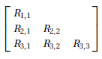, 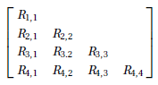

Example:

a. Find $\int_{0}^{π}{sin⁡(x) dx}$ using Trapezoidal Rule 2 panels, 4 panels and Romberg’s, 5 d.p.

b. Find $\int_{0}^{π}{sin⁡(x) dx}$ using Trapezoidal Rule 2 panels, 4 panels, 8 panels, 16 panels and Romberg’s, 5 d.p.

**5. Gauss-Legendre Quadrature**

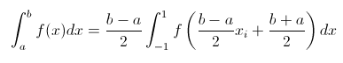

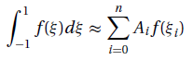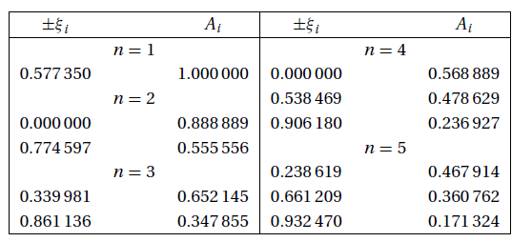

Example:

Find $\int_{-1}^{3}{e^{-x^{2}}dx}$ using Gauss-Legendre Quadrature 3 points, 5 d.p.

**6. Gauss-Chebyshev Quadrature**

$$\int_{-1}^{1}{\frac{f(x)}{\sqrt{1-x^{2}}}dx}=\frac{π}{n}\sum_{k=1}^{n}{f[\cos\left(\frac{2k-1}{2n}π\right)]}$$

If the integral is from x=a to x=b, use transformation $x=\frac{b-a}{2}t+\frac{b+a}{2}$

Example:

Find $\int_{-0.5}^{0.5}{\frac{2x^{2}}{\sqrt{\frac{1}{4}{-x}^{2}}}dx}$ using Gauss-Chebyshev Quadrature 4 points, 5 d.p.

**7. Gauss-Laguerre Quadrature**

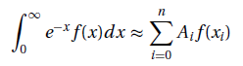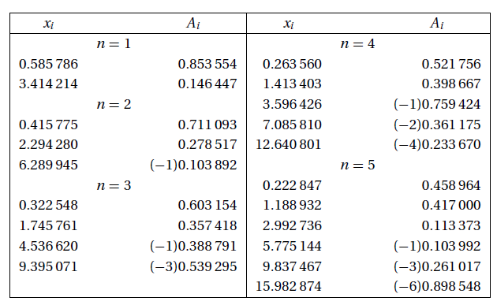

Example:

Find $\int_{0}^{∞}{e^{-x}.{(1-x^{2})}^{3}dx}$ using Gauss-Laguerre Quadrature 2 points, 6 d.p.